LAB 7
UNSTRUCTURED DATABASE LAB
SAZIDUR RAHAMAN
UG/SOET/165/24/001
Q1. Display all documents
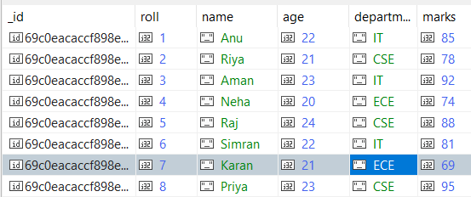
Q2. Find students from IT department
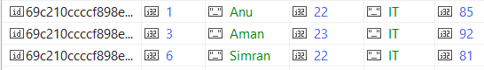
Q3. Find students with marks > 80

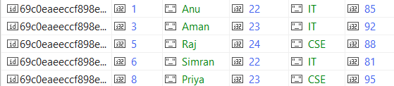
Q4. Insert one new student

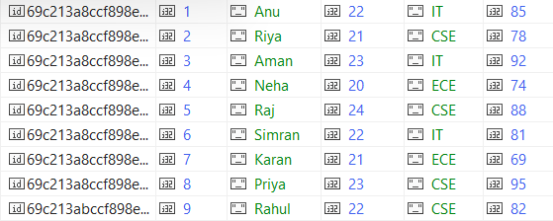
Q5. Update marks of Anu to 90
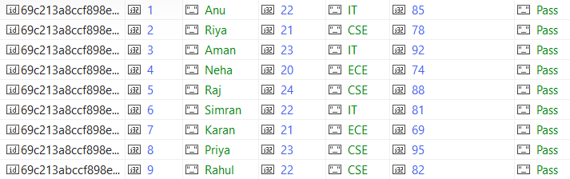
Q6. Add a new field "status: Pass" for all students

Q7. Delete all students with marks < 70
Q8. Count students in CSE department
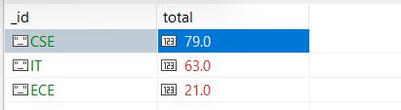
Q9. Find total students in each department
Q10. Find highest marks

Q11. Find the second highest marks

Q12. Find students whose name starts with 'A' and marks > 80

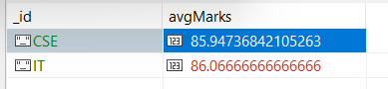
Q13. Display department-wise average marks, only for departments where avg > 80

Q14. Find students with marks between 75 and 90, sorted by marks ascending

Q15. Add grade field based on marks

db.getCollection("studnets").find({})
db.students.insertMany([
{ roll: 1, name: "Anu", age: 22, department: "IT", marks: 85 },
{ roll: 2, name: "Riya", age: 21, department: "CSE", marks: 78 },
{ roll: 3, name: "Aman", age: 23, department: "IT", marks: 92 },
{ roll: 4, name: "Neha", age: 20, department: "ECE", marks: 74 },
{ roll: 5, name: "Raj", age: 24, department: "CSE", marks: 88 },
{ roll: 6, name: "Simran", age: 22, department: "IT", marks: 81 },
{ roll: 7, name: "Karan", age: 21, department: "ECE", marks: 69 },
{ roll: 8, name: "Priya", age: 23, department: "CSE", marks: 95 }
])
db.students.find()
db.students.find({ department: "IT" })

db.students.find({ department: "IT" })

db.students.find({ marks: { $gt: 80 } })
db.students.insertOne(
{ roll: 9, name: "Rahul", age: 22, department: "CSE", marks: 82 }
)
db.students.find().pretty()
db.students.updateOne(
{ name: "Anu" },
{ $set: { marks: 90 } }
)
db.students.find()
db.students.updateMany(
{},
{ $set: { status: "Pass" } }
)
db.students.find()
db.students.deleteMany({ marks: { $lt: 70 } })
db.students.find()
db.students.countDocuments({ department: "CSE" })
db.students.countDocuments({ department: "CSE" })
db.students.aggregate([
{ $group: { _id: "$department", total: { $sum: 1 } } }
])
db.students.find().sort({ marks: -1 }).limit(1)
db.students.find().sort({ marks: -1 }).skip(1).limit(1)
db.students.find({
name: { $regex: "^A" },
marks: { $gt: 80 }
})
db.students.aggregate([
{
$group: {
_id: "$department",
avgMarks: { $avg: "$marks" }
}
},
{
$match: { avgMarks: { $gt: 80 } }
}
])
db.students.find({
marks: { $gte: 75, $lte: 90 }
}).sort({ marks: 1 })
db.students.find({
marks: { $gte: 75, $lte: 90 }
}).sort({ marks: 1 })
db.students.updateMany({}, [
{
$set: {
grade: {
$cond: {
if: { $gte: ["$marks", 90] },
then: "A",
else: {
$cond: {
if: { $gte: ["$marks", 80] },
then: "B",
else: "C"
}
}
}
}
}
}
])

